Solution and Answer Guide
Camm/Cochran/Fry/Ohlmann/Anderson/Sweeney/Williams, Essentials of Modern Business Statistics w/MS Excel 9th Edition, 9780357984505; Chapter 6: Continuous Probability Distributions
Table of Contents
Exercises 1
Supplementary Exercises 21
Case Problem 1: Specialty Toys 32
Case Problem 2: Gebhardt Electronics 36

Exercises
Methods
1. The random variable x is known to be uniformly distributed between 1.0 and 1.5.
a. Show the graph of the probability density function. LO 1, 2
b. Compute P(x = 1.25).
c. Compute P(1.0 ≤ x ≤ 1.25).
d. Compute P(1.20 < x < 1.5).
Solutions:
a.
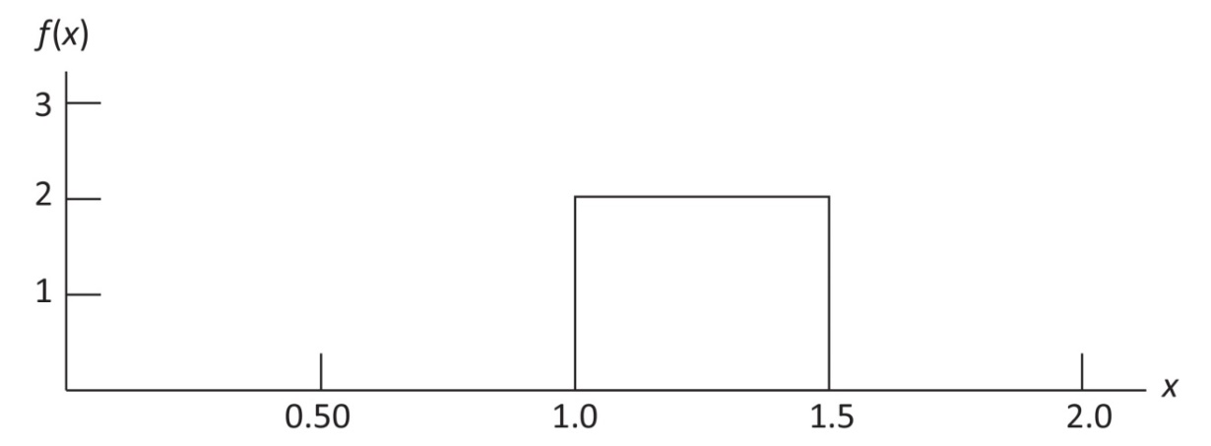
b. P(x = 1.25) = 0. The probability of any single point is zero since the area under the curve above any single point is zero.
c. P(1.0 ≤ x ≤ 1.25) = (1/0.5)(0.25) = 2(0.25) = 0.50
d. P(1.20 < x < 1.5) = (1/0.5)(0.30) = 2(0.30) = 0.60
2. The random variable x is known to be uniformly distributed between 10 and 20.
a. Show the graph of the probability density function. LO 1, 2, 3
b. Compute P(x < 15).
c. Compute P(12 ≤ x ≤ 18).
d. Compute E(x).
e. Compute Var(x).
Solutions:
a.
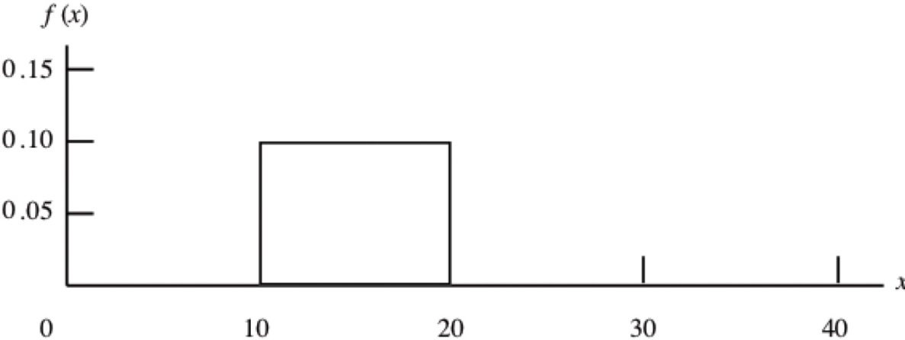
b. P(x < 15) = (1/10)(5) = 0.10(5) = 0.50
c. P(12 ≤ x ≤ 18) = (1/10)(6) = 0.10(6) = 0.60
d.
e.
Applications
3. Cincinnati to Tampa Flight Time. Delta Airlines quotes a flight time of two hours, five minutes for its flights from Cincinnati to Tampa. Suppose we believe that actual flight times are uniformly distributed between two hours and two hours, 20 minutes. LO 1, 2, 3
a. Show the graph of the probability density function for flight time.
b. What is the probability that the flight will be no more than five minutes late?
c. What is the probability that the flight will be more than 10 minutes late?
d. What is the expected flight time?

Solutions:
a.
b. P(x ≤ 130) = (1/20)(130 – 120) = 0.50
c. P(x > 135) = (1/20)(140 – 135) = 0.25
d. minutes
4. Excel RAND Function. Most computer languages include a function that can be used to generate random numbers. In Excel, the RAND function can be used to generate random numbers between zero and one. If we let x denote a random number generated using RAND, then x is a continuous random variable with the following probability density function. LO 1, 2
a. Graph the probability density function.
b. What is the probability of generating a random number between 0.25 and 0.75?
c. What is the probability of generating a random number with a value less than or equal to 0.30?
d. What is the probability of generating a random number with a value greater than 0.60?
e. Generate 50 random numbers by entering = RAND() into 50 cells of an Excel worksheet.
f. Compute the mean and standard deviation for the random numbers in part (e).
Solutions:
a.
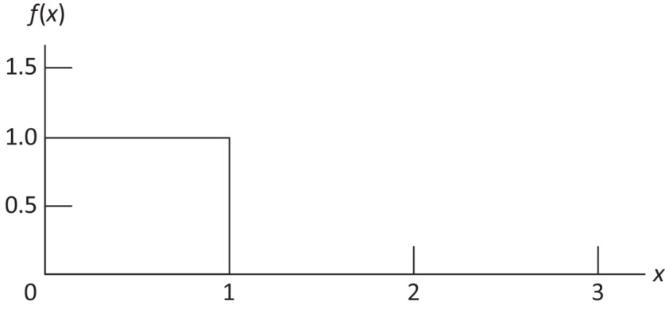
b. P(0.25 < x < 0.75) = 1 (0.50) = 0.50
c. P(x ≤ 0.30) = 1 (0.30) = 0.30
d. P(x > 0.60) = 1 (0.40) = 0.40
e./f. Answers will vary
5. Tesla Battery Recharge Time. The electric-vehicle manufacturing company Tesla estimates that a driver who commutes 50 miles per day in a Model S will require a nightly charge time of around one hour and 45 minutes (105 minutes) to recharge the vehicle’s battery (Tesla company website). Assume that the actual recharging time required is uniformly distributed between 90 and 120 minutes. LO 1, 2
a. Give a mathematical expression for the probability density function of battery recharging time for this scenario.
b. What is the probability that the recharge time will be less than 110 minutes?
c. What is the probability that the recharge time required is at least 100 minutes?
d. What is the probability that the recharge time required is between 95 and 110 minutes?
Solutions:
a. Length of Interval = 120 – 90 = 30
$$f\left(x\right)=\left\{\begin{matrix}\frac{1}{30} \text{for} 90≤x≤120 \\ 0 \text{elsewhere}\end{matrix}\right.$$
b. $P\left(x≤110\right)=\left(110-90\right)\left(\frac{1}{30}\right)=\frac{20}{30}=0.667$
c. $P\left(x≥100\right)=\left(120-100\right)\left(\frac{1}{30}\right)=\frac{20}{30}=0.667$
d. $P\left(95≤x≤110\right)=\left(110-95\right)\left(\frac{1}{30}\right)=\frac{15}{30}=0.5$
6. Daily Discretionary Spending. A Gallup Daily Tracking Survey found that the mean daily discretionary spending by Americans earning over $90,000 per year was $136 per day. The discretionary spending excluded home purchases, vehicle purchases, and regular monthly bills. Let x = the discretionary spending per day and assume that a uniform probability density function applies with f(x) = 0.00625 for a ≤ x ≤ b. LO 1, 2
a. Find the values of a and b for the probability density function.
b. What is the probability that consumers in this group have daily discretionary spending between $100 and $200?
c. What is the probability that consumers in this group have daily discretionary spending of $150 or more?
d. What is the probability that consumers in this group have daily discretionary spending of $80 or less?
Solutions:
a. For a uniform probability density function
Thus, = 0.00625.
Solving for b – a, we have b – a = 1/0.00625 = 160
In a uniform probability distribution, ½ of this interval is below the mean and ½ of this interval is above the mean. Thus,
a = 136 – ½(160) = 56 and b = 136 + ½(160) = 216
b.
c.
d.
7. Bidding on Land. Suppose we are interested in bidding on a piece of land and we know one other bidder is interested. The seller announced that the highest bid in excess of $10,000 will be accepted. Assume that the competitor’s bid x is a random variable that is uniformly distributed between $10,000 and $15,000. LO 2
a. Suppose you bid $12,000. What is the probability that your bid will be accepted?
b. Suppose you bid $14,000. What is the probability that your bid will be accepted?
c. What amount should you bid to maximize the probability that you get the property?
d. Suppose you know someone who is willing to pay you $16,000 for the property. Would you consider bidding less than the amount in part (c)? Why or why not?
Solutions:
a. P(10,000 ≤ x < 12,000) = 2,000 (1/5,000) = 0.40
The probability your competitor will bid lower than you, and you get the bid, is 0.40.
b. P(10,000 ≤ x < 14,000) = 4,000 (1/5,000) = 0.80
c. A bid of $15,000 gives a probability of one of getting the property.
d. Yes, the bid that maximizes expected profit is $13,000.
The probability of winning with the following bids is:
$11,000 Bid P(10,000 < x < 11,000) = 1,000 (1/5,000) = 0.2
$12,000 Bid (from part (a)) = 0.4
$13,000 Bid P(10,000 < x < 13,000) = 3,000 (1/5,000) = 0.6
$14,000 (from part (b)) = 0.8
$15,000 (from part (c)) = 1
The Expected Profit for any bid = P(win)*Profit = P(win)*(16,000-bid), and therefore:
EP ($11,000) = 0.2*5,000 = $1,000
EP ($12,000) = 0.4*4,000 = $1,600
EP ($13,000) = 0.6*3,000 = $1,800
EP ($14,000) = 0.8*2,000 = $1,600
EP ($15,000) = 1*1,000 = $1,000
Methods
8. Using Figure 6.6 as a guide, sketch a normal curve for a random variable x that has a mean of 𝜇 = 100 and a standard deviation of 𝜎 = 10. Label the horizontal axis with values of 70, 80, 90, 100, 110, 120, and 130. LO 4
Solutions:
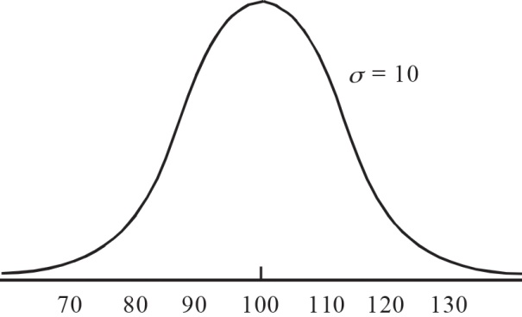
9. A random variable is normally distributed with a mean of 𝜇 = 50 and a standard deviation of 𝜎 = 5. LO 4, 5
a. Sketch a normal curve for the probability density function. Label the horizontal axis with values of 35, 40, 45, 50, 55, 60, and 65. Figure 6.6 shows that the normal curve almost touches the horizontal axis at three standard deviations below and at three standard deviations above the mean (in this case at 35 and 65).
b. What is the probability that the random variable will assume a value between 45 and 55?
c. What is the probability that the random variable will assume a value between 40 and 60?
Solutions:
a. 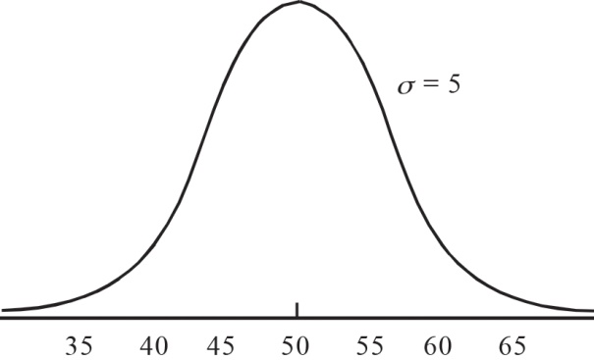
b. 0.683 since 45 and 55 are within plus or minus one standard deviation from the mean of 50 (use the table or see characteristic 7a of the normal distribution).
c. 0.954 since 40 and 60 are within plus or minus two standard deviations from the mean of 50 (use the table or see characteristic 7b of the normal distribution).
10. Draw a graph for the standard normal distribution. Label the horizontal axis at values of
–3, –2, –1, 0, 1, 2, and 3. Then compute the following probabilities. LO 4, 5
a. P(z ≤ 1.5)
b. P(z ≤ 1)
c. P(1 ≤ z ≤ 1.5)
d. P(0 < z < 2.5)
Solutions:
a. P(z ≤ 1.5) = 0.9332 = NORM.S.DIST(1.5,TRUE)
b. P(z ≤ 1.0) = 0.8413 = NORM.S.DIST(1,TRUE)
c. P(1 ≤ z ≤ 1.5) = P(z ≤ 1.5) – P(z < 1) = 0.9932 – 0.8413 = 0.0919
OR = NORM.S.DIST(1.5,TRUE)–NORM.S.DIST(1,TRUE) = 0.0918
d. P(0 < z < 2.5) = P(z < 2.5) – P(z ≤ 0) = 0.9938 – 0.5000 = 0.4938
OR = NORM.S.DIST(2.5,TRUE)–NORM.S.DIST(0,TRUE)
11. Given that z is a standard normal random variable, compute the following probabilities. LO 5
a. P(z ≤ –1.0)
b. P(z ≥ –1)
c. P(z ≥ –1.5)
d. P(–2.5 ≤ z)
e. P(–3 < z ≤ 0)
Solutions:
a. P(z ≤ –1) = 0.1587 = NORM.S.DIST(–1,TRUE)
b. P(z ≥ –1) = 1 – P(z < –1) = 1 – 0.1587 = 0.8413 = 1–NORM.S.DIST(–1,TRUE)
- (z ≥ –1.5) = 1 – P(z < –1.5) = 1 – 0.0668 = 0.9332 = 1–NORM.S.DIST(–1.5,TRUE)
d. P(–2.5 ≤ z) = 1 – P(z < –2.5) = 1 – 0.0062 = 0.9938 = 1–NORM.S.DIST(–2.5,TRUE)
e. P(–3 < z ≤ 0) = P(z ≤ 0) – P(z ≤ –3) = 0.5000 – 0.0013 = 0.4987
OR = NORM.S.DIST(0,TRUE)–NORM.S.DIST(–3,TRUE)
12. Given that z is a standard normal random variable, compute the following probabilities. LO 5
a. P(0 ≤ z ≤ 0.83)
b. P(–1.57 ≤ z ≤ 0)
c. P(z > 0.44)
d. P(z ≥ –0.23)
e. P(z < 1.20)
f. P(z ≤ –0.71)
Solutions:
a. P(0 ≤ z ≤ 0.83) = P(z < 0.83) – P(z < 0) = 0.7967 – 0.5000 = 0.2967
OR = NORM.S.DIST(0.83,TRUE)–NORM.S.DIST(0,TRUE)
b. P(–1.57 ≤ z ≤ 0) = P(z < 0) – P(z < –1.57) = 0.5000 – 0.0582 = 0.4418
OR = NORM.S.DIST(0,TRUE) – NORM.S.DIST(–1.57,TRUE)
c. P(z > 0.44) = 1 – P(z < 0.44) = 1 – 0.6700 = 0.3300 = 1–NORM.S.DIST(0.44,TRUE)
d. P(z ≥–0.23) = 1 – P(z <–0.23) = 1 – 0.4090 = 0.5910 = 1–NORM.S.DIST(–0.23,TRUE)
e. P(z < 1.20) = 0.8849 = NORM.S.DIST(1.2,TRUE)
f. P(z ≤ –0.71) = 0.2389 = NORM.S.DIST(–0.71,TRUE)
13. Given that z is a standard normal random variable, compute the following probabilities. LO 5
a. P(–1.98 ≤ z ≤ 0.49)
b. P(0.52 ≤ z ≤ 1.22)
c. P(–1.75 ≤ z ≤ –1.04)
Solutions:
a. P(–1.98 ≤ z ≤ 0.49) = P(z ≤ 0.49) – P(z < –1.98) = 0.6879 – 0.0239 = 0.6640
OR = NORM.S.DIST(0.49,TRUE)–NORM.S.DIST(–1.98,TRUE) = 0.6641
b. P(0.52 ≤ z ≤ 1.22) = P(z ≤ 1.22) – P(z < 0.52) = 0.8888 – 0.6985 = 0.1903
OR = NORM.S.DIST(1.22,TRUE)–NORM.S.DIST(0.52,TRUE)
c. P(–1.75 ≤ z ≤ –1.04) = P(z ≤ –1.04) – P(z < –1.75) = 0.1492 – 0.0401 = 0.1091
OR = NORM.S.DIST(–1.04,TRUE)–NORM.S.DIST(–1.75,TRUE)
14. Given that z is a standard normal random variable, find z for each situation. LO 6
a. The area to the left of z is 0.9750.
b. The area between zero and z is 0.4750.
c. The area to the left of z is 0.7291.
d. The area to the right of z is 0.1314.
e. The area to the left of z is 0.6700.
f. The area to the right of z is 0.3300.
Solutions:
a. The z value corresponding to a cumulative probability of 0.9750 is z = 1.96.
OR =NORM.S.INV(0.975) = 1.96
b. Since the area to the left of z = 0 is 0.5, the z value here also corresponds to a cumulative probability of 0.9750: z = 1.96.
OR =NORM.S.INV(0.975) = 1.96
c. The z value corresponding to a cumulative probability of 0.7291 is z = 0.61.
OR =NORM.S.INV(0.7291) = 0.61
d. Area to the left of z is 1 – 0.1314 = 0.8686. So z = 1.12.
OR =NORM.S.INV(0.8686) = 1.12
e. The z value corresponding to a cumulative probability of 0.6700 is z = 0.44.
OR =NORM.S.INV(0.67) = 0.44
f. The area to the left of z is 0.6700. So z = 0.44.
OR =NORM.S.INV(0.67) = 0.44
15. Given that z is a standard normal random variable, find z for each situation. LO 6
a. The area to the left of z is 0.2119.
b. The area between –z and z is 0.9030.
c. The area between –z and z is 0.2052.
d. The area to the left of z is 0.9948.
e. The area to the right of z is 0.6915.
Solutions:
a. The z value corresponding to a cumulative probability of 0.2119 is z = –0.80.
OR =NORM.S.INV(0.2119) = –0.80
b. Compute 0.9030/2 = 0.4515; z corresponds to a cumulative probability of 0.5000
+ 0.4515 = 0.9515. So z = 1.66.
OR =NORM.S.INV(0.9515) = 1.66
c. Compute 0.2052/2 = 0.1026; z corresponds to a cumulative probability of 0.5000
+ 0.1026 = 0.6026. So z = 0.26.
OR =NORM.S.INV(0.6026) = 0.26
d. The z value corresponding to a cumulative probability of 0.9948 is z = 2.56.
OR =NORM.S.INV(0.9948) = 2.56
e. The area to the left of z is 1 – 0.6915 = 0.3085. So z = –0.50.
OR =NORM.S.INV(0.3085) = –0.50
16. Given that z is a standard normal random variable, find z for each situation. LO 6
a. The area to the right of z is 0.01.
b. The area to the right of z is 0.025.
c. The area to the right of z is 0.05.
d. The area to the right of z is 0.10.
Solutions:
a. The area to the left of z is 1 – 0.0100 = 0.9900. The z value in the table with a cumulative probability closest to 0.9900 is z = 2.33.
OR =NORM.S.INV(0.99) = 2.33
b. The area to the left of z is 0.9750. So z = 1.96.
OR =NORM.S.INV(0.975) = 1.96
c. The area to the left of z is 0.9500. Since 0.9500 is exactly halfway between 0.9495
(z = 1.64) and 0.9505 (z = 1.65), we select z = 1.645. However, z = 1.64 or z = 1.65 are also acceptable answers. NORM.S.INV(0.95)
d. The area to the left of z is 0.9000. So z = 1.28 is the closest z value.
OR =NORM.S.INV(0.9) = 1.28
Applications
17. Height of Dutch Males. Those assigned the sex of male at birth in the Netherlands are the tallest, on average, in the world with an average height of 183 centimeters (cm) (BBC News website). Assume that the height of males in the Netherlands is normally distributed with a mean of 183 cm and standard deviation of 10.5 cm. LO 5
a. What is the probability that a Dutch male is shorter than 175 cm?
b. What is the probability that a Dutch male is taller than 195 cm?
c. What is the probability that a Dutch male is between 173 and 193 cm?
d. Out of a random sample of 1,000 Dutch males, how many would we expect to be taller than 190 cm?
Solutions:
μ = 183 and σ = 10.5
a. $z=\frac{x-μ}{σ}=\frac{175-183}{10.5}=-0.76$
$$P\left(x≤175\right)=P\left(z≤-0.76\right)=0.2236$$
Using Excel: NORM.DIST(175,183,10.5,TRUE) = 0.2231
The probability that a Dutch male is shorter than 175 cm is 0.2236 (or 0.2231 from Excel).
b. $z=\frac{x-μ}{σ}=\frac{195-183}{10.5}=1.14$
$$P\left(x≥175\right)=1-P\left(x≤175\right)=1-P\left(z≤1.14\right)=1-0.8729=0.1271$$
Using Excel: 1–NORM.DIST(195,183,10.5,TRUE) = 0.1265
The probability that a Dutch male is taller than 195 cm is 0.1271 (or 0.1265 using Excel).
c. For x = 193, $z=\frac{x-μ}{σ}=\frac{193-183}{10.5}=0.95$
For x = 173, $z=\frac{x-μ}{σ}=\frac{173-183}{10.5}=-0.95$
P(173 ≤ x ≤ 193) = $P\left(z≤0.95\right)-P\left(z≤-0.95\right)=0.8289-0.1711=0.6578$
Using Excel NORM.DIST(193,183,10.5,TRUE)–NORM.DIST(173,183,10.5,TRUE) = 0.6591
The probability that a Dutch male is between 173 cm and 193 cm is 0.6578 (or 0.6591 from Excel).
d. $z=\frac{x-μ}{σ}=\frac{190-183}{10.5}=0.67$
$$P\left(x>190\right)=1-P\left(x≤190\right)=1-P\left(z≤0.67\right)=1-0.7486=0.2514$$
Using Excel: 1–NORM.DIST(190,183,10.5,TRUE) = 0.2525
So, we would expect about 0.2514(1,000) = 251.4, or approximately 251 (or 253 using Excel) Dutch males out of a random sample of 1,000, to be taller than 190 cm.
18. Large-Cap Domestic Stock Fund. The average return for large-cap domestic stock funds over three years was 14.4%. Assume the three-year returns were normally distributed across funds with a standard deviation of 4.4%. LO 5, 6
a. What is the probability an individual large-cap domestic stock fund had a three-year return of at least 20%?
b. What is the probability an individual large-cap domestic stock fund had a three-year return of 10% or less?
c. How big does the return have to be to put a domestic stock fund in the top 10% for the three-year period?
Solutions:
μ = 14.4 and σ = 4.4
a. At x = 20,
P(z ≤ 1.27) = 0.8980
P(x > 20) = P(z > 1.27) = 1 – P(z < 1.27) = 1 – 0.8980 = 0.1020
Using Excel: 1–NORM.DIST(20,14.4,4.4,TRUE) = 0.1016
b. At x = 10,
P(z ≤ –1.00) = 0.1587
So, P(x ≤ 10) = 0.1587
Using Excel: 1–NORM.DIST(10,14.4,4.4,TRUE) = 0.1587
c. A z value of 1.28 cuts off an area of approximately 10% in the upper tail.
x = 14.4 + 4.4(1.28) = 20.03
A return of 20.03% or higher will put a domestic stock fund in the top 10%.
Using Excel: 1–NORM.INV(0.9,14.4,4.4) = 20.0388 or 20.04%
19. Automobile Repair Costs. Automobile repair costs continue to rise with the average cost now at $367 per repair (U.S. News & World Report website). Assume that the cost for an automobile repair is normally distributed with a standard deviation of $88. Answer the following questions about the cost of automobile repairs. LO 5, 6
a. What is the probability that the cost will be more than $450?
b. What is the probability that the cost will be less than $250?
c. What is the probability that the cost will be between $250 and $450?
d. If the cost for your car repair is in the lower 5% of automobile repair charges, what is your cost?
Solutions:
a. μ = 367 and σ = 88.
The probability that the cost will be more than $450 is 0.1736.
Using Excel: 1–NORM.DIST(450,367,88,TRUE) = 0.1728
b.
The probability that the cost will be less than $250 is 0.0918.
Using Excel: NORM.DIST(250,367,88,TRUE) = 0.0918
c.
The probability that the cost will be between $250 and $450 is 0.7346.
Using Excel: NORM.DIST(450,367,88,TRUE)–NORM.DIST(250,367,88,TRUE) = 0.7354
d. Lower 5% occurs for z = –1.645
For a car repair in the lower 5%, the cost must be $222.24 or less.
Using EXCEL: NORM.INV(0.05,367,88) = $222.25
20. Basketball Game. Suppose that the Fort Wayne Mad Ants are playing the Cleveland Charge in a basketball game. The number of points scored in a game by the Mad Ants is normally distributed with a mean of 107 and standard deviation of 13. The number of points scored in a game by the Charge is normally distributed with a mean of 111 and standard deviation of 19. LO 5
a. What is the probability that the Mad Ants will score more than 100 points in a game?
b. What percentage of games would you expect the Charge to score more than 120 points in a game?
c. What is the probability that the Mad Ants will score more points in a game than the mean number of points scored by the Charge?
Solutions:
a. Mad Ants: $μ=107, σ=13$
For $x=100, z=\frac{100-107}{13}=-0.54$
$$P\left(z≤-0.54\right)=0.2946$$
So, $P\left(x>100\right)=1-P\left(z≤-0.54\right)=1-0.2946=0.7054$
Using Excel, 1–NORM.DIST(100,107,13,1) = 0.7049
So, the probability the Mad Ants will score more than 100 points in a game is about 0.70.
b. Charge: $μ=111, σ=19$
For $x=120, z=\frac{120-111}{19}=0.47$
$$P\left(z≤0.47\right)=0.6808$$
So, $P\left(x>120\right)=1-P\left(z≤0.47\right)=1-0.6808=0.3192$
Using Excel, 1–NORM.DIST(120,111,19,1) = 0.3179
So, we would expect the Charge to score more than 120 points in about 32% of games.
c. Mad Ants: $μ=107, σ=13$
For $x=111, z=\frac{111-107}{13}=0.31$
$$P\left(z≤0.31\right)=0.6217$$
So, $P\left(x>107\right)=1-P\left(z≤0.31\right)=1-0.6217=0.3783$
Using Excel, 1–NORM.DIST(111,107,13,1) = 0.3792
So, the probability the Mad Ants score more than the mean number of points scored by the Charge (111) is about 0.38.
21. Leadtime Quotes for Steel Production. A certain cold-rolled steel product requires a production lead time that is normally distributed with a mean of 7.6 days and standard deviation of 2.8 days. If the company wants to quote a lead time to a customer such that the company is 90% confident that it will produce the product in less than the quoted lead time, what lead time should it quote to the customer? LO 6
Solutions:
From the standard normal probability table, a z value of 1.29 corresponds to a probability value > 0.90. Therefore,
$$x=μ+zσ=7.6+1.29\left(2.8\right)=11.21$$
Using Excel, =NORM.INV(0.9,7.6,2.8) = 11.19.
Therefore, the company should quote a lead time of around 11.2 days to be 90% confident that it can produce the product in the quoted lead time.
22. Screen Time. Suppose that the mean time someone spends using a device with a screen such as a smartphone, computer, or television is 8.35 hours. Use a normal probability distribution with a standard deviation of 2.5 hours to answer the following questions about daily screen time. LO 5, 6
a. What is the probability that a randomly selected person has between five and 10 hours of screen time a day?
b. How many hours of screen time must a person have in order to be in the top 3% of all screen time values?
c. What is the probability that a person has more than three hours of screen time a day?
Solutions:
Use μ = 8.35 and σ = 2.5
a. We want to find P(5 ≤ x ≤10)
At x = 10,
At x = 5,
P(5 ≤ x ≤ 10) = P(–1.34 ≤ z ≤ 0.66)= P(z ≤ 0.66) – P(z ≤ –1.34)
= 0.7454 – 0.0901
= 0.6553
Using Excel: NORM.DIST(10,8.35,2.5,TRUE) – NORM.DIST(5,8.35,2.5,TRUE) = 0.6553
The probability a person has a screen time between five and 10 hours a day is 0.6553.
b. Find the z value that cuts off an area of 0.03 in the upper tail. Using a cumulative probability of 1 – 0.03 = 0.97, z = 1.88 provides an area of 0.03 in the upper tail of the normal distribution.
x = μ + zσ = 8.35 + 1.88(2.5) = 13.05 hours
Using Excel: NORM.INV(0.97,8.35,2.5) = 13.0520
A person must have over 13 hours of screen time a day to be in the top 3% of screen time values.
c. At x = 3,
P(x > 3) = P(z > –2.14) = 1 – P(z< –2.14) = 1 – 0.0162 = 0.9838
Using Excel: 1–NORM.DIST(3,8.35,2.5) = 0.9838
The probability a person has more than three hours of screen time a day is 0.9838.
23. Time to Complete Final Exam. The time needed to complete a final examination in a particular college course is normally distributed with a mean of 80 minutes and a standard deviation of 10 minutes. Answer the following questions. LO 5
a. What is the probability of completing the exam in one hour or less?
b. What is the probability that a student will complete the exam in more than 60 minutes but less than 75 minutes?
c. Assume that the class has 60 students and that the examination period is 90 minutes in length. How many students do you expect will be unable to complete the exam in the allotted time?
Solutions:
a. P(x < 60) = P(z ≤ –2) = 0.0228. So P(x < 60) = 0.0228
Using Excel: NORM.DIST(60,80,10,TRUE) = 0.0228
b. At x = 60
Area to left is 0.0228.
At x = 75
Area to left is 0.3085.
P(60 ≤ x ≤ 75) = P(–2 < z < –0.5) = P(z <–0.5) – P(z < –2) = 0.3085 – 0.0228 = 0.2857
Using Excel: NORM.DIST(75,80,10,TRUE) – NORM.DIST(60,80,10,TRUE) = 0.2858
c. P(x > 90) = P(z > 1) = 1 – P(z < 1) = 1 – 0.8413 = 0.1587
Using Excel: 1–NORM.DIST(90,80,10,TRUE) = 0.1587
Therefore, 15.87% of students will not complete on time.
(60) (0.1587) = 9.522
We would expect 10 students to be unable to complete the exam in time.
24. Amount of Sleep. The United States Centers for Disease Control and Prevention (CDC) recommends that adults sleep seven to nine hours per night (CDC.gov). However, many adults in the United States sleep less than seven hours per night. Suppose that the amount of sleep for an adult in the United States follows a normal distribution with a mean of 8.0 hours and standard deviation of 1.7 hours. LO 5, 6
a. What is the probability that an adult in the United States sleeps less than 7.0 hours?
b. What is the probability that an adult in the United States sleeps between 7.0 and
9.0 hours?
c. How many hours of sleep would an adult in the United States get if they are in the 10th percentile of this distribution?
Solutions:
μ = 8.0 and σ = 1.7
a. $z=\frac{x-μ}{σ}=\frac{7.0-8,0}{1.7}=-0.59$
$$P\left(x≤7.0\right)= P\left(z≤-0.59\right)=0.2776$$
The probability that the adult sleeps less than 7.0 hours is 0.2776.
b. For x = 9.0, $z=\frac{x-μ}{σ}=\frac{9.0-8,0}{1.7}=0.59$
For x = 7.0, $z=\frac{x-μ}{σ}=\frac{7.0-8,0}{1.7}=-0.59$
P(7.0 ≤ x ≤ 9.0) = $P\left(z≤0.59\right)-P(z≤-0.59$= 0.7224 – 0.2776 = 0.4448
The probability that they will sleep between 7.0 and 9.0 hours is 0.4448.
c. For the 10th percentile, $z=-1.28$
$$x=μ+zσ=8.0+\left(-1.28)(1.7\right)=5.824$$
An adult in the 10th percentile sleeps 5.824 hours.
25. Real per Capita Income by State. Nominal income refers to an income value that is not adjusted for inflation. Real income adjusts the nominal value for the rate of inflation. Real income per capita is considered a good measure of the buying power of an individual in a particular area because it adjusts for both the number of people in the area and the relative inflation of the area. According to Forbes magazine, the state with the highest annual real income per capita in 2020 is Connecticut with a real per capita income of $68,533. Suppose that the annual real income of individuals in Connecticut follows a normal distribution with a mean of $68,533 and standard deviation of $23,480. LO 5, 6
a. What is the probability that an individual in Connecticut has an annual real income of $50,000 or more?
b. What is the probability that an individual in Connecticut has an annual real income of $30,000 or less?
c. What is the probability that an individual in Connecticut has an annual real income between $60,000 and $80,000?
d. What is the annual real income of a person in the 99th percentile of annual real income in Connecticut?
Solutions:
μ = 68,533 and σ = 23,480
a. $z=\frac{x-μ}{σ}=\frac{50,000-68,533 }{23,480}=-0.79$
$$P\left(x≥50,000\right)=1-P\left(x≤50,000\right)=1-P\left(z≤-0.79\right)=1-0.2148=0.7852$$
The probability that a household income is more than $50,000 is 0.7852.
b. $z=\frac{x-μ}{σ}=\frac{30,000-68,533 }{23,480}=-1.64$
$$P\left(x≤30,000\right)=P\left(z≤-1.64\right)=0.0505$$
The probability that a household income is $30,000 or less is 0.0505.
c. For x = 80,000, $z=\frac{x-μ}{σ}=\frac{80,000-68,533 }{23,480}=0.49$
For x = 60,000,
$$z=\frac{x-μ}{σ}=\frac{60,000-68,533 }{23,480}=-0.36$$
P(60,000 ≤ x ≤ 80,000) = $P\left(z≤0.49\right)-P\left(z≤-0.36\right)=0.6879-0.3594=0.3285$
The probability that a household income is between $60,000 and $80,000 is 0.3285.
d. The 99th percentile occurs at z = 2.33.
$$x=μ+zσ=68,533+2.33\left(23,480\right)=123,231.40.$$
The 99th percentile of annual household income in Connecticut is $123,241.40.
Methods
26. Consider the following exponential probability density function. LO 7
a. Find P(x ≤ 6).
b. Find P(x ≤ 4).
c. Find P(x ≥ 6).
d. Find P(4 ≤ x ≤ 6).
Solutions:
μ = 8
a. P(x ≤ 6) = 1 – e^{–6/8} = 1 – 0.4724 = 0.5276
Using Excel: EXPON.DIST(6,1/8,TRUE) = 0.5276
b. P(x ≤ 4) = 1 – e^{–4/8} = 1 – 0.6065 = 0.3935
Using Excel: EXPON.DIST(4,1/8,TRUE) = 0.3935
c. P(x ≥ 6) = 1 – P(x ≤ 6) = 1 – 0.5276 = 0.4724
Using Excel: =1–EXPON.DIST(6,1/8,TRUE) = 0.4724
d. P(4 ≤ x ≤ 6) = P(x ≤ 6) – P(x ≤ 4) = 0.5276 – 0.3935 = 0.1341
Using Excel: EXPON.DIST(6,1/8,TRUE)–EXPON.DIST(4,1/8,TRUE) = 0.1342
27. Consider the following exponential probability density function. LO 7
a. Write the formula for P(x ≤ x₀).
b. Find P(x ≤ 2).
c. Find P(x ≥ 3).
d. Find P(x ≤ 5).
e. Find P(2 ≤ x ≤ 5).
Solutions:
μ = 3
a.
b. P(x ≤ 2) = 1 – e^{–2/3} = 1 – 0.5134 = 0.4866
Using Excel: EXPON.DIST(2,1/3,TRUE) = 0.4866
c. P(x ≥ 3) = 1 – P(x ≤ 3) = 1 – (1 – e^{–3/3}) = e^{–1} = 0.3679
Using Excel: =1–EXPON.DIST(3,1/3,TRUE) = 0.3679
d. P(x ≤ 5) = 1 – e^{–5/3} = 1 – 0.1889 = 0.8111
Using Excel: EXPON.DIST(5,1/3,TRUE) = 0.8111
e. P(2 ≤ x ≤ 5) = P(x ≤ 5) – P(x ≤ 2) = 0.8111 – 0.4866 = 0.3245
Using Excel: EXPON.DIST(5,1/3,TRUE)–EXPON.DIST(2,1/3,TRUE) = 0.3245
Applications
28. Phone Battery Life. Battery life between charges for a certain mobile phone is 20 hours when the primary use is talk time, and drops to seven hours when the phone is primarily used for Internet applications over cellular. Assume that the battery life in both cases follows an exponential distribution. LO 7, 8
a. Show the probability density function for battery life for this phone when its primary use is talk time.
b. What is the probability that the battery charge for a randomly selected phone will last no more than 15 hours when its primary use is talk time?
c. What is the probability that the battery charge for a randomly selected phone will last more than 20 hours when its primary use is talk time?
d. What is the probability that the battery charge for a randomly selected phone will last no more than five hours when its primary use is Internet applications?
Solutions:
a. With μ = 20,
b. P(x ≤ 15) = = 0.5276
Using Excel: EXPON.DIST(15,1/20,TRUE) = 0.5276
c. P(x > 20) = 1 – P(x ≤ 20)
= 1 – () =
Using Excel: 1–EXPON.DIST(20,1/20,TRUE) = 0.3679
d. With μ = 7,
Using Excel: EXPON.DIST(5,1/7,TRUE) = 0.5105
29. Arrival of Vehicles to an Intersection. The time between arrivals of vehicles at a particular intersection follows an exponential probability distribution with a mean of 12 seconds. LO 7, 8
a. Sketch this exponential probability distribution.
b. What is the probability that the arrival time between vehicles is 12 seconds or less?
c. What is the probability that the arrival time between vehicles is six seconds or less?
d. What is the probability of 30 or more seconds between vehicle arrivals?
Solutions:
a.
μ = 12
b. P(x ≤ 12) = 1 – e^{–12/12} = 1 – 0.3679 = 0.6321
Using Excel: EXPON.DIST(12,1/12,TRUE) = 0.6321
c. P(x ≤ 6) = 1 – e^{-6/12} = 1 – 0.6065 = 0.3935
Using Excel: EXPON.DIST(6,1/12,TRUE) = 0.3935
d. P(x ≥ 30) = 1 – P(x < 30)
= 1 – (1 – e^{-30/12})
= 0.0821
Using Excel: =1-EXPON.DIST(30,1/12,TRUE) = 0.0821
30. Comcast Service Operations. Comcast Corporation is a global telecommunications company headquartered in Philadelphia, PA. Generally known for reliable service, the company periodically experiences unexpected service interruptions. When service interruptions do occur, Comcast customers who call the office receive a message providing an estimate of when service will be restored. Suppose that for a particular outage, Comcast customers are told that service will be restored in two hours. Assume that two hours is the mean time to do the repair and that the repair time has an exponential probability distribution. LO 7
a. What is the probability that the cable service will be repaired in one hour or less?
b. What is the probability that the repair will take between one hour and two hours?
c. For a customer who calls the Comcast office at 1:00 p.m., what is the probability that the cable service will not be repaired by 5:00 p.m.?
Solutions:
μ = 2
a. for x > 0
P(x < x₀) =
P(x < 1) = = 1 – 0.6065 = 0.3935
Using Excel: EXPON.DIST(1,1/2,TRUE) = 0.3935
b. P(x < 2) = = 1 – 0.3679 = 0.6321
= 0.6321 – 0.3935 = 0.2386
Using Excel: EXPON.DIST(2,1/2,TRUE)–EXPON.DIST(1,1/2,TRUE) = 0.2387
c. For this customer, the cable service repair would have to take longer than four hours.
Using Excel: 1–EXPON.DIST(4,1/2,TRUE) = 0.1353
31. Patient Length of Stays in ICUs. Intensive care units (ICUs) generally treat the sickest patients in a hospital. ICUs are often the most expensive department in a hospital because of the specialized equipment and extensive training required to be an ICU doctor or nurse. Therefore, it is important to use ICUs as efficiently as possible in a hospital. According to
a 2017 large-scale study of elderly ICU patients, the average length of stay in the ICU is
3.4 days (Critical Care Medicine journal article). Assume that this length of stay in the ICU has an exponential distribution. LO 7
a. What is the probability that the length of stay in the ICU is one day or less?
b. What is the probability that the length of stay in the ICU is between two and three days?
c. What is the probability that the length of stay in the ICU is more than five days?
Solutions:
a. $f\left(x\right)=\frac{1}{μ}e^{-x/μ}=\frac{1}{3.4}e^{-x/3.4}$ for x > 0
P(x < x₀) = $1-e^{-\frac{x_{0}}{μ}}=1-e^{-\frac{x_{0}}{3.4}}$
P(x < 1) = $1-e^{-\frac{1}{3.4}}=1-0.7452=0.2548$
Using Excel: EXPON.DIST(1,1/3.4,TRUE) = 0.2548
b. P(x ≤ x₀) = $1-e^{-\frac{3}{3.4}}=1-0.4138= 0.5862$
P(x ≤ 1) = $1-e^{-\frac{2}{3.4}}=1-0.5553= 0.4447$
P(2 ≤ x ≤ 3) = P(x ≤ 3) – P(x ≤ 2) = 0.5862 – 0.4447 = 0.1415
Using Excel: EXPON.DIST(3,1/3.4,TRUE)–EXPON.DIST(2,1/3.4,TRUE) = 0.1415
c. P(x > 5) = 1 – P(x ≤ 5) = 1 – (1 – e^{–5/3.4}) = e^{–1.4706} = 0.2298
Using Excel: 1–EXPON.DIST(5,1/3.4,TRUE) = 0.2298
32. Boston 911 Calls. The Boston Fire Department receives 911 calls at a mean rate of 1.6 calls per hour (Mass.gov website). Suppose the number of calls per hour follows a Poisson probability distribution. LO 7, 8
a. What is the mean time between 911 calls to the Boston Fire Department in minutes?
b. Using the mean in part (a), show the probability density function for the time between 911 calls in minutes.
c. What is the probability that there will be less than one hour between 911 calls?
d. What is the probability that there will be 30 minutes or more between 911 calls?
e. What is the probability that there will be more than five minutes but less than
20 minutes between 911 calls?
Solutions:
a. Because the number of calls per hour follows a Poisson distribution, the time between calls follows an exponential distribution. So, for a mean of 1.6 calls per hour, the mean time between calls is
b. The exponential probability density function is f (x) = for where x is the minutes between 911 calls.
c. Using time in minutes,
Using Excel: EXPON.DIST(60,1/37.5,TRUE) = 0.7981
d.
Using Excel: 1–EXPON.DIST(30,1/37.5,TRUE) = 0.4493
e.
Using Excel: EXPON.DIST(20,1/37.5,TRUE)–EXPON.DIST(5,1/37.5,TRUE) = 0.2885

Supplementary Exercises
33. Selling a House. A business executive, transferred from Chicago to Atlanta, needs to sell her house in Chicago quickly. The executive’s employer has offered to buy the house for $310,000, but the offer expires at the end of the week. The executive does not currently have a better offer, but can afford to leave the house on the market for another month. From conversations with her realtor, the executive believes the price she will get by leaving the house on the market for another month is uniformly distributed between $300,000 and $325,000. LO 1, 2
a. If she leaves the house on the market for another month, what is the mathematical expression for the probability density function of the sales price?
b. If she leaves it on the market for another month, what is the probability that she will get at least $315,000 for the house?
c. If she leaves it on the market for another month, what is the probability that she will get less than $310,000?
d. Should the executive leave the house on the market for another month? Why or why not?
Solutions:
a. Let x = sales price ($1000s)
b. P(x ≥ 315) = (1/25) (325 − 315) = 0.40
c. P(x < 310) = (1/25)(310 − 300) = 0.40
d. E(x) = (300 + 325)/2 = 312,500
If the executive leaves the house on the market for another month, the expected sales price will be $2,500 higher than if the house is sold back to the company for $310,000. However, if the house is left on the market for another month, there is a 0.40 probability that the executive will get less than the company offer of $310,000. It is a close call. But the expected value of $312,500 suggests the executive should leave the house on the market another month.
34. Stock Returns. Suppose the annual return for a certain class of stocks is normally distributed with a mean of 11.4% and a standard deviation of 9.6%. LO 5, 6
a. What is the probability that a randomly selected stock from this class of stocks with have an annual return of more than 15%?
b. What is the probability a randomly selected stock from this class of stocks will have a negative annual return?
c. What annual return would you expect from a stock in this class of stocks that outperforms 90% of all stocks in this class?
Solutions:
a. μ = 0.114 and σ = 0.096
For x = 0.15,
$$z=\frac{0.15-0.114}{0.096}=0.38$$
$$P\left(x>0.15\right)=1-P\left(x≤0.15\right)=1-P\left(z≤0.38\right)=1-0.6480=0.3520$$
Using Excel, 1–NORM.DIST(0.15,0.114,0.096,TRUE) = 0.3583.
b. For x = 0,
$$z=\frac{0-0.114}{0.096}=-1.19$$
$$P\left(x≤0\right)=P\left(z≤-1.19\right)=0.1170$$
Using Excel, NORM.DIST(0,0.114,0.096,TRUE) = 0.1175
c. The z value corresponding to area of 0.90 under the standard normal curve is approximately 1.29.
Therefore, the annual return of a stock that outperforms 90% of stocks in this class is: 0.114 + 1.29(0.096) = 0.238. So, the annual return of a stock that outperforms 90% of the stocks in this class is approximately 23.8%.
Using Excel NORM.INV(0.90,0.114,0.096) = 0.237.
35. Production Defects. Motorola used the normal distribution to determine the probability of defects and the number of defects expected in a production process. Assume a production process produces items with a mean weight of 10 ounces. LO 5
a. Suppose that the process standard deviation is 0.15, and the process control is set at plus or minus one standard deviation. Units with weights less than 9.85 or greater than 10.15 ounces will be classified as defects. Calculate the probability of a defect and the expected number of defects for a 1,000-unit production run.
b. Suppose that through process design improvements, the process standard deviation can be reduced to 0.05. Assume the process control remains the same, with weights less than 9.85 or greater than 10.15 ounces being classified as defects. Calculate the probability of a defect and the expected number of defects for a 1,000-unit production run.
c. What is the advantage of reducing process variation, thereby causing process control limits to be at a greater number of standard deviations from the mean?
Solutions:
a. μ = 10 and σ = 0.15
P(defect) = 1 – P(9.85 ≤ x ≤ 10.15), with σ = 0.15, z = ±1
= 1 – P(–1 ≤ z ≤ 1) = 1 – 0.6826 = 0.3174
Using Excel: 1–[NORM.DIST(10.15,10,0.15,TRUE)–NORM.DIST(9.85,10,0.15,TRUE)]
= 0.3173
Expected number of defects = 1,000(0.3174) = 317.4
b. μ = 10 and σ = 0.05
P(defect) = 1 – P(9.85 ≤ x ≤ 10.15), with σ = 0.05, z = ±3
= 1 – P(–3 ≤ z ≤ 3) = 1 – 0.9974 = 0.0026
Using Excel: 1–[NORM.DIST(10.15,10,0.05,TRUE)–NORM.DIST(9.85,10,0.05,TRUE)]
= 0.0027
Expected number of defects = 1,000(0.0026) = 2.6
c. Reducing the process standard deviation causes a substantial reduction in the number of defects.
36. Bringing Items to a Pawnshop. One indicator of the level of economic hardship in a community is the number of people who bring items to a pawnshop. Assume the number of people bringing items to the pawnshop per day is normally distributed with a mean of 658. LO 5, 6
a. Suppose you learn that on 3% of the days, 610 or fewer people brought items to the pawnshop. What is the standard deviation of the number of people bringing items to the pawnshop per day?
b. On any given day, what is the probability that between 600 and 700 people bring items to the pawnshop?
c. How many people bring items to the pawnshop on the busiest 3% of days?
Solutions:
μ = 658
a. z = –1.88 cuts off 0.03 in the lower tail
So,
Using EXCEL: NORM.S.INV(0.03), z = –1.8807936, solving for σ without rounding, gives 25.5211.
b. At 700,
At 600,
P(600 < x < 700) = P(–2.31 < z < 1.65) = P(z < 1.65) – P(z < –2.31) = 0.9505 – 0.0104
= 0.9401
Using Excel: NORM.DIST(700,658,25.5211,TRUE)–NORM.DIST(600,658,25.5211,TRUE)
= 0.9386
c. z = 1.88 cuts off approximately 0.03 in the upper tail
x = 658 + 1.88(25.5319) = 706.
Using Excel: NORM.INV(0.97,658,25.5211) = 706
On the busiest 3% of days 706 or more people show up at the pawnshop.
37. Amazon Alexa App Downloads. Alexa is the popular virtual assistant developed by Amazon. Alexa interacts with users using artificial intelligence and voice recognition. It can be used to perform daily tasks such as making to-do lists, reporting the news and weather, and interacting with other smart devices in the home. In 2018, the Amazon Alexa app was downloaded some 2,800 times per day from the Google Play store (AppBrain website). Assume that the number of downloads per day of the Amazon Alexa app is normally distributed with a mean of 2,800 and standard deviation of 860. LO 5, 6
a. What is the probability there are 2,000 or fewer downloads of Amazon Alexa in a day?
b. What is the probability there are between 1,500 and 2,500 downloads of Amazon Alexa in a day?
c. What is the probability there are more than 3,000 downloads of Amazon Alexa in a day?
d. Assume that Google has designed its servers so there is probability 0.01 that the number of Amazon Alexa app downloads in a day exceeds the servers’ capacity and more servers have to be brought online. How many Amazon Alexa app downloads per day are Google’s servers designed to handle?
Solutions:
μ = 2,800 and σ = 860
a. $z=\frac{x-μ}{σ}=\frac{2,000-2,800}{860}=-0.93$
$$P\left(x≤2,000\right)=P\left(z≤-0.93\right)=0.1762$$
Using Excel: NORM.DIST(2000,2800,860,TRUE) = 0.1761
b. For x = 2,500,
$$z=\frac{x-μ}{σ}=\frac{2,500-2,800}{860}=-0.35$$
For x = 1,500,
$$z=\frac{x-μ}{σ}=\frac{1,500-2,800}{860}=-1.51$$
$$P\left(1,500≤x≤2,500\right)=P\left(z≤-0.35\right)-P\left(z≤-1.51\right)=0.3632-0.0655=0.2977$$
Using Excel: NORM.DIST(2500,2800,860,TRUE)–NORM.DIST(1500,2800,860,TRUE)
= 0.2983
c. For x = 3,000,
$$z=\frac{x-μ}{σ}=\frac{3,000-2,800}{860}=0.23$$
$$P\left(x>3,000\right)=1-P\left(z≤0.23\right)=1-0.5910=0.4090$$
Using Excel: 1–NORM.DIST(3000,2800,860,TRUE) = 0.4081
d. The z value for 1 – 0.01 = 0.99 is 2.33. Therefore, Google must design their servers to handle $μ+zσ=2,800+2.33\left(860\right)=4,803.8$ (or about 4,804) downloads per day.
Using Excel: NORM.INV(0.99,2800,860) = 4800.7 (or about 4801) downloads per day
38. Service Contract Offer. Ward Doering Auto Sales is considering offering a special service contract that will cover the total cost of any service work required on leased vehicles. From experience, the company manager estimates that yearly service costs are approximately normally distributed, with a mean of $150 and a standard deviation of $25. LO 5
a. If the company offers the service contract to customers for a yearly charge of $200, what is the probability that any one customer’s service costs will exceed the contract price of $200?
b. What is Ward’s expected profit per service contract?
Solutions:
a. At x = 200,
P(x > 200) = P(z > 2) = 1 – P(z ≤ 2) = 1 – 0.9772 = 0.0228
Using Excel: 1–NORM.DIST(200,150,25,TRUE) = 0.0228
b. Expected Profit = Expected Revenue – Expected Cost
= 200 – 150 = $50
39. Wedding Costs. The XO Group Inc. conducted a 2015 survey of 13,000 brides and grooms married in the United States and found that the average cost of a wedding is $29,858 (XO Group website). Assume that the cost of a wedding is normally distributed with a mean of $29,858 and a standard deviation of $5,600. LO 5, 6
a. What is the probability that a wedding costs less than $20,000?
b. What is the probability that a wedding costs between $20,000 and $30,000?
c. For a wedding to be among the 5% most expensive, how much would it have to cost?
Solutions:
𝜇 = 29,858 σ = 5,600
a. At x = 20,000,
P(x < 20,000) = P(z < –1.76) = 0.0392
Using Excel: NORM.DIST(20000,29858,5600,TRUE) = 0.0392
b. At x = 30,000,
P(x < 30,000) = P(z < 0.03) = 0.5120
P(x < 20,000) = 0.0392 (from part a)
P(20,000 < x < 30,000) = P(–1.76 < z < 0.03) = P(z < 0.03) – P(z < –1.76) = 0.5120
– 0.0392 = 0.4728
Using Excel: NORM.DIST(30000,29858,5600,TRUE)–NORM.DIST(20000,29858,5600,TRUE) = 0.4709
c. Find the z value that cuts off an area of 0.05 in the upper tail: z = 1.645
Solve for x,
x = 29,858 + 1.645(5,600) = 39,070
Using Excel: NORM.INV(0.95,29858,5600) = 39069
A wedding cost of $39,070 or more would put a wedding among the 5% most expensive.
40. College Admissions Test Scores. Assume that the test scores from a college admissions test are normally distributed, with a mean of 450 and a standard deviation of 100. LO 5, 6
a. What percentage of the people taking the test score between 400 and 500?
b. Suppose someone receives a score of 630. What percentage of the people taking the test score better? What percentage score worse?
c. If a particular university will not admit anyone scoring below 480, what percentage of the persons taking the test would be acceptable to the university?
Solutions:
μ = 450 and σ = 100
a. At 400,
Area to left is 0.3085.
At 500,
Area to left is 0.6915.
P(400 ≤ x ≤ 500) = P(–0.5 < z < 0.5) = P(z < 0.5) – P(z <–0.5) = 0.6915 – 0.3085 = 0.3830
Using Excel: NORM.DIST(500,450,100,TRUE)–NORM.DIST(400,450,100,TRUE) = 0.3829
38.3% will score between 400 and 500.
b. At 630,
Probability of worse than 630 = P(x < 630) = P(z < 1.8) = 0.9641
Using Excel: NORM.DIST(630,450,100,TRUE) = 0.9641
Probability of better than 630 = P(x > 630) = P(z > 1.8) = 1 – P(z < 1.8) = 1 – 0.9641
= 0.0359
Using Excel: 1–NORM.DIST(630,450,100,TRUE) = 1 – 0.9641 = 0.0359
96.41% do worse and 3.59% do better.
c. At 480,
Area to left is 0.6179.
Probability of admittance = P(x > 480) = P(z > 0.3) = 1 – P(z < 0.3) = 1 – 0.6179 = 0.3821
Using Excel: 1–NORM.DIST(480,450,100,TRUE) = 1 – 0.6179 = 0.3821
38.21% are acceptable.
41. College Graduates Starting Salaries. According to Forbes magazine, the 2023 average starting salary for new college graduates in humanities was $50,681. The average starting salary for new college graduates in engineering was $73,922 (Forbes.com website). Assume that starting salaries are normally distributed and that the standard deviation for starting salaries for new college graduates in humanities is $14,000. Assume that the standard deviation for starting salaries for new college graduates in engineering is $19,000. LO 5, 6
a. What is the probability that a new college graduate in engineering will earn a starting salary of at least $80,000?
b. What is the probability that a new college graduate in humanities will earn a starting salary of at least $80,000?
c. What is the probability that a new college graduate in humanities will earn a starting salary less than $50,000?
d. How much would a new college graduate in engineering have to earn in order to have a starting salary higher than 99% of all starting salaries of new college graduates in humanities? What percentage of engineering students are expected to earn a starting salary higher than 99% of all starting salaries of humanities graduates?
Solutions:
For part (a): μ = 73,922 and σ = 19,000
a. At x = 80,000,
$$z=\frac{80,000-73,922}{19,000}=0.32$$
P(x > 80,000) = P(z > 0.32) = 1 – P(z ≤ 0.32) = 1 – 0.6255 = 0.3775
The probability of an engineering graduate having a starting salary more than $80,000 is 0.3775.
Using Excel: 1–NORM.DIST(80000,73922,19000,TRUE) = 0.3745
For parts (b), (c), and (d): μ = 50,681 and σ = 14,000
b. At x = 80,000,
$$z=\frac{80,000-50,681}{14,000}=2.09$$
P(x > 80,000) = P(z > 2.09) = 1 – P(z ≤ 2.09) = 1 – 0.9817 = 0.0183
The probability of a health science graduate having a starting salary more than $80,000 is 0.0183.
Using Excel: 1–NORM.DIST(80000,50681,14000,TRUE) = 0.0182
c. At x = 50,000,
$$z=\frac{50,000-50,681}{14,000}=-0.05$$
P(x < 50,000) = P(z < –0.05) = 0.4801
The probability of a health science graduate having a starting salary less than $50,000 is 0.4801.
Using Excel: NORM.DIST(50000,50681,14000,TRUE) = 0.4806
d. The answer to this is the humanities graduate starting salary that cuts off an area of 0.01 in the upper tail of the distribution for humanities graduate starting salaries.
Use z = 2.33
x = 50,681 + 2.33(14,000) = 83,481
Using Excel: NORM.INV(0.99,50681,14000) = 83249
An engineering graduate would have to obtain a starting salary of at least $83,481 (or $83,249) to have a starting salary higher than 99% of all starting salaries for new college graduates with a major in humanities.
For engineering graduates, μ = 73,922 and σ = 19,000.
At x = 83,481,
$$z=\frac{83,481-73,922}{19,000}=0.50$$
P(x > 83,481) = P(z > 0.50) = 1 – P(z ≤ 0.50) = 1 – 0.6915 = 0.3085
The probability of an engineering graduate having a starting salary higher than 99% of humanities graduates is 0.3085.
Using the values from Excel: 1 – NORM.DIST(83249,73922,19000,TRUE) = 0.3118 (or 0.3074 if you use the $83,481 values found from the standard normal table).
42. Filling Weights. A machine fills containers with a particular product. The standard deviation of filling weights is known from past data to be 0.6 ounce. If only 2% of the containers hold less than 18 ounces, what is the mean filling weight for the machine? That is, what must μ equal? Assume the filling weights have a normal distribution. LO 6
Solutions:
𝜎 = 0.6
At 2%,
z ≈ –2.05 x = 18
𝜇 = 18 + 2.05 (0.6) = 19.23 oz
The mean filling weight must be 19.23 oz.
43. Mean Time Between Failures. The mean time between failures (MTBF) is a common metric used to measure the performance of manufacturing systems. MTBF is the elapsed time between failures of a system during normal operations. The failures could be caused by broken machines or computer errors, among other failures. Suppose that the MTBF for a new automated manufacturing system follows an exponential distribution with a mean of 12.7 hours. LO 7
a. What is the probability that the automated manufacturing system runs for more than 15 hours without a failure?
b. What is the probability that the automated manufacturing system runs for eight or fewer hours before failure?
c. What is the probability that the automated manufacturing system runs for more than six hours but less than 10 hours before a failure?
Solutions:
a. $P\left(x>15\right)=1-P\left(x≤15\right)=1-\left(1-e^{-\frac{15}{12.7}}\right)=1-0.6931= 0.3069$
Using Excel: 1–EXPON.DIST(15,1/12.7,TRUE) = 0.3069
b. $P\left(x≤8\right)=1-e^{-\frac{8}{12.7}}=0.4674$
Using Excel: EXPON.DIST(8,1/12.7,TRUE) = 0.4674
c. $P\left(x≤6\right)=1-e^{-\frac{6}{12.7}}=0.3765$
$$P\left(x≤10\right)=1-e^{-\frac{10}{12.7}}=0.5450$$
The probability that the system runs between six and 10 hours before a failure is $0.5450-0.3765=0.1685$.
Using Excel: EXPON.DIST(10,1/12.7,TRUE)–EXPON.DIST(6,1/12.7,TRUE) = 0.1685
44. Website Traffic. A website for bed and breakfast inns gets approximately seven visitors per minute. Suppose the number of website visitors per minute follows a Poisson probability distribution. LO 7, 8
a. What is the mean time between visits to the website?
b. Show the exponential probability density function for the time between website visits.
c. What is the probability that no one will access the website in a one-minute period?
d. What is the probability that no one will access the website in a 12-second period?
Solutions:
a. Mean time between arrivals = 1/7 minutes
b. f(x) = 7e^{–7x}
c. P(no one in 1 minute) = P(greater than 1 minute between arrivals)
= P(x > 1) = 1 – P(x < 1) = 1 – [1 – e^{–7(1)}] = e^{–7} = 0.0009
Using Excel: 1–EXPON.DIST(1,1/(1/7),TRUE) = 1–EXPON.DIST(1,7,TRUE) = 0.0009
OR: POISSON.DIST(0, 7, TRUE) = 0.0009
d. 12 seconds is 0.2 minutes, or 1/5 of a minute, therefore Poisson mean = 7/5 per
12 seconds = 1.4
Using exponential, P(no one in 12 seconds = P(greater than 12 seconds between arrivals) = P(x > 0.2) = 1 – P(x < 0.2) = 1 – [1 – e^{–7(0.2)}] = e^{–1.4} = 0.2466
Using Excel: 1–EXPON.DIST(0.2,1/(1/7),TRUE) = 1–EXPON.DIST(0.2,7,TRUE) = 0.2466
OR: POISSON.DIST(0,7/5,TRUE) = 0.2466
45. Waiting in Line at Kroger. Supermarket chain Kroger has used computer simulation and information technology to reduce the average waiting time for customers at 2,300 stores. Using a new system called QueVision, which allows Kroger to better predict when shoppers will be checking out, the company was able to decrease average customer waiting time to just 26 seconds (InformationWeek website). LO 7
a. Assume that Kroger waiting times are exponentially distributed. Show the probability density function of waiting time at Kroger.
b. What is the probability that a customer will have to wait between 15 and 30 seconds?
c. What is the probability that a customer will have to wait more than two minutes?
Solutions:
μ = 26
a. for x > 0
b. P(x < x₀) =
P(x < 30) = 1 – 0.3154 = 0.6846
P(x < 15) = 1 – 0.5932 = 0.4384
P(15 < x < 30) = P(x < 30) – P(x < 15) = 0.6846 – 0.4384 = 0.2462
Using Excel: EXPON.DIST(30,1/26,TRUE) – EXPON.DIST(15,1/26,TRUE) = 0.2462
c. P(x > 120) = 1 – P(x < 120) =
Using Excel: = 1–EXPON.DIST(120,1/26,TRUE) = 0.0099
There is less than a 1% chance of waiting more than two minutes.
46. Calls to Insurance Claims Office. The time (in minutes) between telephone calls at an insurance claims office has the following exponential probability distribution. LO 7, 8
f(x) = 0.50e^{–0.50x} for x ≥ 0
a. What is the mean time between telephone calls?
b. What is the probability of having 30 seconds or less between telephone calls?
c. What is the probability of having one minute or less between telephone calls?
d. What is the probability of having five or more minutes without a telephone call?
Solutions:
a. therefore μ = 2 minutes = mean time between telephone calls
b. Note: 30 seconds = 0.5 minutes
P(x ≤ 0.5) = 1 – e^{–0.5/2} = 1 – 0.7788 = 0.2212
Using Excel: EXPON.DIST(0.5,1/2,TRUE) = 0.2212
c. P(x ≤ 1) = 1 – e^{–1/2} = 1 – 0.6065 = 0.3935
Using Excel: 1–EXPON.DIST(1,1/2,TRUE) = 0.2212
d. P(x ≥ 5) = 1 – P(x < 5) = 1 – (1 – e^{–5/2}) = 0.0821
Using Excel: 1–EXPON.DIST(5,1/2,TRUE) = 0.0821
47. Laffy Taffy Candy Production. Laffy Taffy is a type of taffy candy made from corn syrup, sugar, palm oil, and other ingredients. Laffy Taffy comes in a variety of flavors including strawberry, banana, and cherry. Suppose that Laffy Taffy is produced as a continuous length of taffy on an extrusion machine. Defects can occur in the taffy including large air bubbles and tears. Assume that the distance between such defects follows an exponential distribution with a mean of 523 meters. LO 7
a. What is the probability that the machine will produce more than 1,000 meters of taffy before the next defect is observed?
b. What is the probability that the next defect will be observed before the machine produces 500 meters or less of taffy?
Solutions:
Mean distance between defects = 523 meters.
a. $P\left(x>1,000\right)=1-P\left(x≤1,000\right)=1-\left(1-e^{-\frac{1}{523}*1,000}\right)=1-(1-0.1478)=0.1478$
The probability that the machine will produce more than 1,000 meters of taffy before the next defect is 0.1478.
b. $P\left(x≤500\right)=1-e^{-\frac{1}{523}*500}=1-0.3844=0.6156$
The probability that the machine will produce 500 meters or less of taffy before the next defect is 0.6156.

Case Problem 1: Specialty Toys
Specialty Toys, Inc. sells a variety of new and innovative children’s toys. Management learned that the preholiday season is the best time to introduce a new toy, because many families use this time to look for new ideas for December holiday gifts. When Specialty discovers a new toy with good market potential, it chooses an October market entry date.
In order to get toys into its stores by October, Specialty places one-time orders with its manufacturers in June or July of each year. Demand for children’s toys can be highly volatile. If a new toy catches on, a sense of shortage in the marketplace often increases the demand to high levels and large profits can be realized. However, new toys can also flop, leaving Specialty stuck with high levels of inventory that must be sold at reduced prices. The most important question the company faces is deciding how many units of a new toy should be purchased to meet anticipated sales demand. If too few are purchased, sales will be lost; if too many are purchased, profits will be reduced because of low prices realized in clearance sales.
For the coming season, Specialty plans to introduce a new product called Weather Teddy. This variation of a talking teddy bear is made by a company in Taiwan. When a child presses Teddy’s hand, the bear begins to talk. A built-in barometer selects one of five responses that predict the weather conditions. The responses range from “It looks to be a very nice day! Have fun” to “I think it may rain today. Don’t forget your umbrella.” Tests with the product show that, even though it is not a perfect weather predictor, its predictions are surprisingly good. Several of Specialty’s managers claimed Teddy gave predictions of the weather that were as good as those of many local television weather forecasters.
As with other products, Specialty faces the decision of how many Weather Teddy units to order for the coming holiday season. Members of the management team suggested order quantities of 15,000, 18,000, 24,000, or 28,000 units. The wide range of order quantities suggested indicates considerable disagreement concerning the market potential. The product management team asks you for an analysis of the stock-out probabilities for various order quantities, an estimate of the profit potential, and help with making an order quantity recommendation. Specialty expects to sell Weather Teddy for $24 based on a cost of $16 per unit. If inventory remains after the holiday season, Specialty will sell all surplus inventory for $5 per unit. After reviewing the sales history of similar products, Specialty’s senior sales forecaster predicted an expected demand of 20,000 units with a 0.95 probability that demand would be between 10,000 units and 30,000 units. LO 3, 4, 5, 6
Managerial Report
Prepare a managerial report that addresses the following issues and recommends an order quantity for the Weather Teddy product.
1. Use the sales forecaster’s prediction to describe a normal probability distribution that can be used to approximate the demand distribution. Sketch the distribution and show its mean and standard deviation.
2. Compute the probability of a stock-out for the order quantities suggested by members of the management team.
3. Compute the projected profit for the order quantities suggested by the management team under three scenarios: worst case in which sales = 10,000 units, most likely case in which sales = 20,000 units, and best case in which sales = 30,000 units.
4. One of Specialty’s managers felt that the profit potential was so great that the order quantity should have a 70% chance of meeting demand and only a 30% chance of any stock-outs. What quantity would be ordered under this policy, and what is the projected profit under the three sales scenarios?
5. Provide your own recommendation for an order quantity and note the associated profit projections. Provide a rationale for your recommendation.
Solutions:
1. Information provided by the forecaster
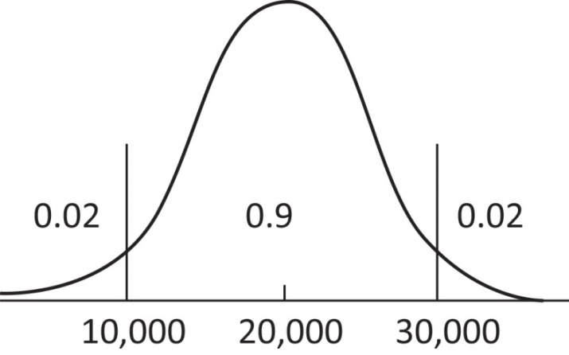
At x = 30,000,
Therefore,
Normal distribution
2. At x = 15,000,
P(stockout) = 1 – 0.1635 = 0.8365
Using Excel: 1–NORM.DIST(15000,20000,5102,TRUE) = 0.8365
At x = 18,000,
P(stockout) = 1 – 0.3483 = 0.6517
Using Excel: 1–NORM.DIST(18000,20000,5102,TRUE) = 0.6525
At x = 24,000,
P(stockout) = 1 – 0.7823 = 0.2177
Using Excel: 1–NORM.DIST(24000,20000,5102,TRUE) = 0.2165
At x = 28,000,
P(stockout) = 1 – 0.9418 = 0.0582
Using Excel: P(stockout) = 1–NORM.DIST(28000,20000,5102,TRUE) = 0.0584
3. Profit projections for the order quantities under the three scenarios are computed below:
Order Quantity: 15,000
 |  | Sales
Unit Sales | Total Cost | at $24 | at $5 | Profit
10,000 | 240,000 | 240,000 | 25,000 | 25,000
20,000 | 240,000 | 360,000 | 0 | 120,000
30,000 | 240,000 | 360,000 | 0 | 120,000
Order Quantity: 18,000
 |  | Sales
Unit Sales | Total Cost | at $24 | at $5 | Profit
10,000 | 288,000 | 240,000 | 40,000 | –8,000
20,000 | 288,000 | 432,000 | 0 | 144,000
30,000 | 288,000 | 432,000 | 0 | 144,000
Order Quantity: 24,000
 |  | Sales
Unit Sales | Total Cost | at $24 | at $5 | Profit
10,000 | 384,000 | 240,000 | 70,000 | –74,000
20,000 | 384,000 | 480,000 | 20,000 | 116,000
30,000 | 384,000 | 576,000 | 0 | 192,000
Order Quantity: 28,000
 |  | Sales
Unit Sales | Total Cost | at $24 | at $5 | Profit
10,000 | 448,000 | 240,000 | 90,000 | –118,000
20,000 | 448,000 | 480,000 | 40,000 | 72,000
30,000 | 448,000 | 672,000 | 0 | 224,000
4. We need to find an order quantity that cuts off an area of 0.70 in the lower tail of the normal curve for demand.
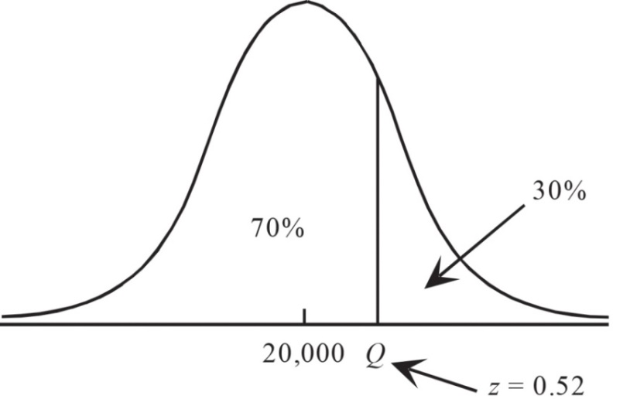
Q = 20,000 + 0.52(5,102) = 22,653
Using Excel: NORM.INV(0.7,20000,5102) = 22675.5 (or about 22676)
The projected profits under the three scenarios are computed below.
Order Quantity: 22,653
 |  | Sales
Unit Sales | Total Cost | at $24 | at $5 | Profit
10,000 | 362,488 | 240,000 | 63,265 | –59,183
20,000 | 362,488 | 480,000 | 13,265 | 130,817
30,000 | 362,488 | 543,672 | 0 | 181,224
5. A variety of recommendations are possible. The students should justify their recommendation by showing the projected profit obtained under the three scenarios used in parts three and four. An order quantity in the 18,000 to 20,000 range strikes a good compromise between the risk of a loss and generating good profits.
While the students don’t have the benefit of the following, a single-period inventory model (sometimes called the news vendor model) shows how to find an optimal solution. We outline that solution below.
A single-period inventory model recommends an order quantity that maximizes expected profit based on the following formula:
where is the probability that demand is less than or equal to the recommended order quantity,. is the cost of underestimating demand (having lost sales because of a stockout) andis the cost per unit of overestimating demand (having unsold inventory). Specialty will sell Weather Teddy for $24 per unit. The cost is $16 per unit. So, = $24 – $16 = $8. If inventory remains after the holiday season, Specialty will sell all surplus inventory for $5 a unit. So, = $16 – $5 = $11.
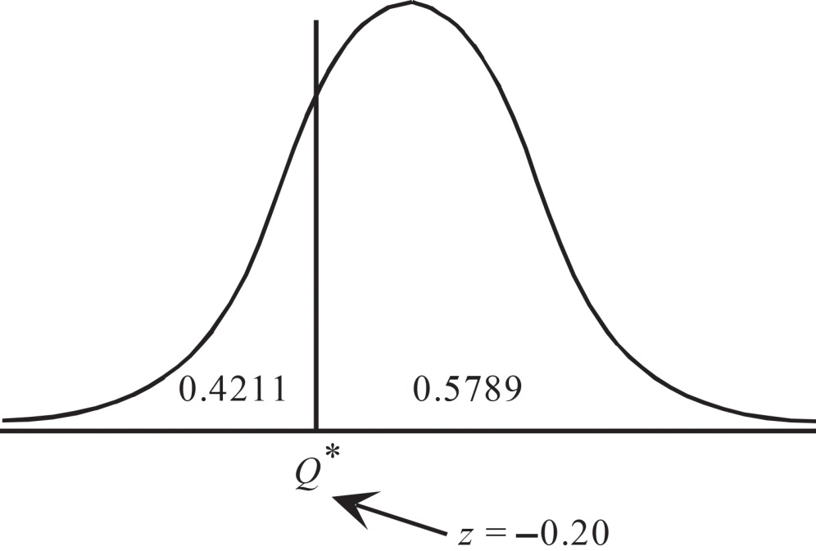
Using Excel: NORM.INV(0.4211,20000,5102) = 18984.3 (or about 18984)
The profit projections for this order quantity are computed below:
Order Quantity: 18,980
 |  | Sales
Unit Sales | Total Cost | at $24 | at $5 | Profit
10,000 | 303,680 | 240,000 | 44,900 | –18,780
20,000 | 303,680 | 455,520 | 0 | 151,840
30,000 | 303,680 | 455,520 | 0 | 151,840

Case Problem 2: Gebhardt Electronics
Gebhardt Electronics produces a wide variety of transformers that it sells directly to manufacturers of electronics equipment. For one component used in several models of its transformers, Gebhardt uses a three-foot length of 0.20-mm diameter solid wire made of pure Oxygen-Free Electronic (OFE) copper. A flaw in the wire reduces its conductivity and increases the likelihood it will break, and this critical component is difficult to reach and repair after a transformer has been constructed. Therefore, Gebhardt wants to use primarily flawless lengths of wire in making this component. The company is willing to accept no more than a one in 20 chance that a three-foot length taken from a spool will be flawless. Gebhardt also occasionally uses smaller pieces of the same wire in the manufacture of other components, so the three -foot segments to be used for this component are essentially taken randomly from a long spool of 0.20-mm diameter solid OFE copper wire.
Gebhardt is now considering a new supplier for copper wire. This supplier claims that its spools of 0.20-mm diameter solid OFE copper wire average 50 inches between flaws. Gebhardt now must determine whether the new supply will be satisfactory if the supplier’s claim is valid. LO 7, 8
Managerial Report
In making this assessment for Gebhardt Electronics, consider the following three questions:
1. If the new supplier does provide spools of 0.20-mm solid OFE copper wire that average
50 inches between flaws, how is the length of wire between two consecutive flaws distributed?
2. Using the probability distribution you identified in (1), what is the probability that Gebhardt’s criteria will be met (i.e., a one in 20 chance that a randomly selected three-foot segment of wire provided by the new supplier will be flawless)?
3. In inches, what is the minimum mean length between consecutive flaws that would result in satisfaction of Gebhardt’s criteria?
4. In inches, what is the minimum mean length between consecutive flaws that would result in a one in 100 chance that a randomly selected three-foot segment of wire provided by the new supplier will be flawless?
Solutions:
1. The random variable x is the distance in inches between consecutive flaws on a length
of 0.20-mm diameter solid OFE copper. Thus, if the new supplier provides spools of
0.20-mm solid OFE copper wire that average μ = 50 inches between flaws, the length
of wire between two consecutive flaws is exponentially distributed, i.e.,
2. The probability the distance in inches between consecutive flaws on a length of0.20-mm diameter solid OFE copper is less than or equal to 36 is
$$P\left(x≤36\right)=1-e^{\frac{-36}{50}}=0.5132$$
Using Excel: EXPON.DIST(36,1/50,TRUE) = 0.5132.
Thus, the probability the distance in inches between consecutive flaws on a length of 0.20-mm diameter solid OFE copper exceeds 36 is
P(x > 36) = 1 – P(x ≤ 36) = 0.4868.
Using Excel: 1–EXPON.DIST(36,1/50,TRUE) = 0.4868
0.4868 > 0.01, so Gebhardt’s criteria will not be met by the new supplier.
3. Using the function $1-P\left(x≤36\right)=1-(1-e^{-\frac{36}{μ_{0}}})$ [which can be done using the Excel formula = 1 – EXPON.DIST(36,1/µ₀,TRUE)] for values of µ₀ in increments of one starting with
50, we find that Gebhardt’s criteria is not met until the mean umber of inches between consecutive flaws is 702, i.e.,
$$1-P\left(x≤36\right)=e^{-\frac{36}{702}}=0.9500$$
4. Using the function $1-P\left(x≤36\right)=1-(1-e^{-\frac{36}{μ_{0}}})$ [which can be done using the Excel formula =1 – EXPON.DIST(36,1/ µ₀,TRUE)] for values of µ₀ in increments of one starting with 702, we find that the minimum mean length between consecutive flaws that would result in a one in 100 chance that a randomly selected 3-foot segment of wire provided by the new supplier will be flawless is 3,582, i.e.,
$$P\left(x>36\right)=1-P\left(x≤36\right)=e^{-\frac{36}{3,582}}=0.9900$$

This exercise is based on a problem suggested to us by Professor Roger Myerson of Northwestern University.

